**1.Introduction**

* We can use Chrome console to write and test javascript.
* 5 Primitive Data types (Numbers, Strings, Booleans, null, undefined). Strings -> Single and double quotes both ok rest are normal (string.lenght/ string[0] etc). Concat two string with + operator.
* The Variables that are declared but not initialized are set to undefined. Null is “explicitly nothing”.
* Alert(“”) -> opens a notification for user , promt(“”) -> promt for something from user, console.log(“”)-> prints on console only , clear()-> clears screen.
* <script src=””></script> is how to add the js file. If we put wrong filename/path it will show on console that the file wasn’t found.

**2.Basics**

* **Operators**

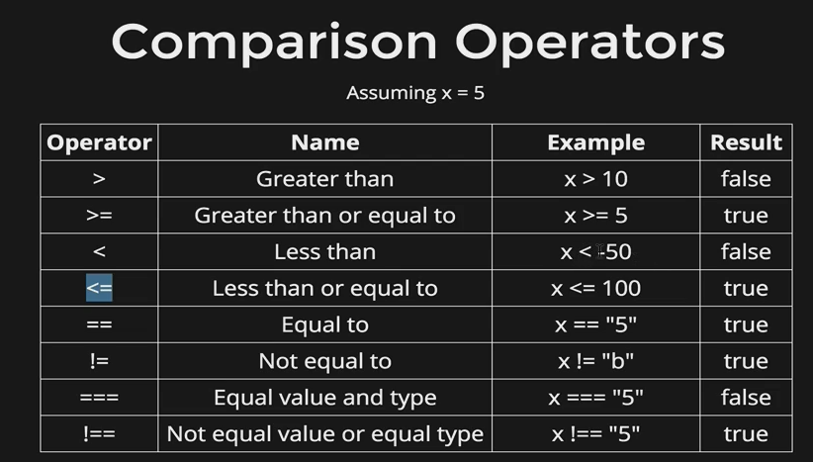

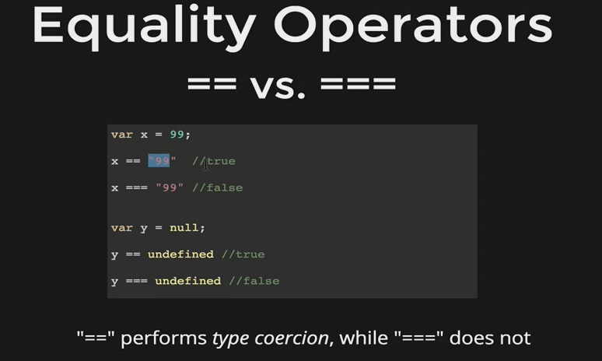

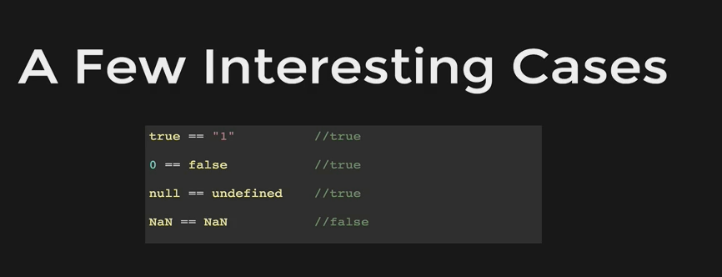

* **Logical Operators**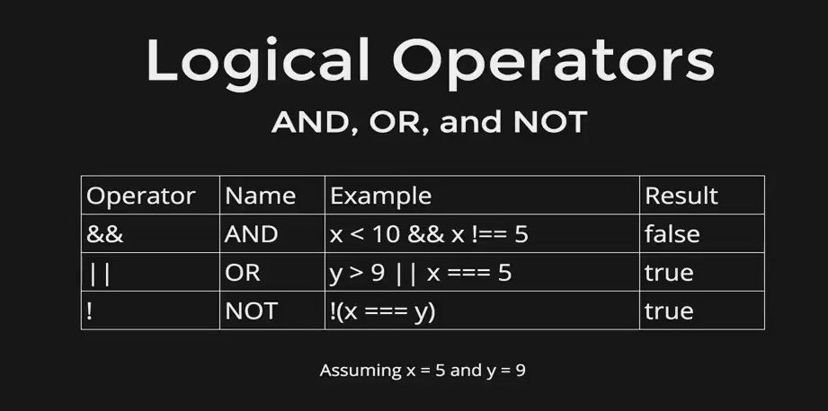
* **Loops:** Do while, While, for loop -> you know already.
* **Functions** -> you know already mostly. 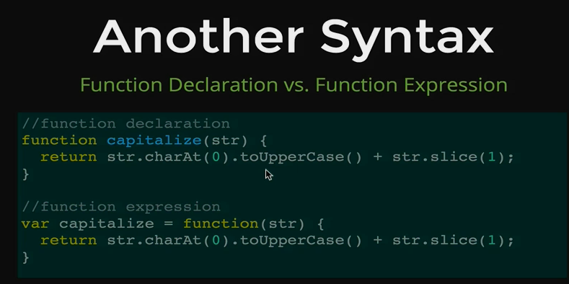
* We can pass functions as argument inside a function. We don’t need parenthesis when we use function as argument. For example -> setInterval(somefunction, 200);
* **Array** example -> var friends= [“Charlie”,” Liz”];
* **Array Method -> push/pop** -> like stack, **shift/unshift** -> add first item to an array, removes first item of an array, **indexof() ->** returns the index of the element, **slice(x,y)** -> to copy part of the array, x is starting index and y is the ending index. Rest of the methods we can look up at documentation
* **Array Iteration** ->

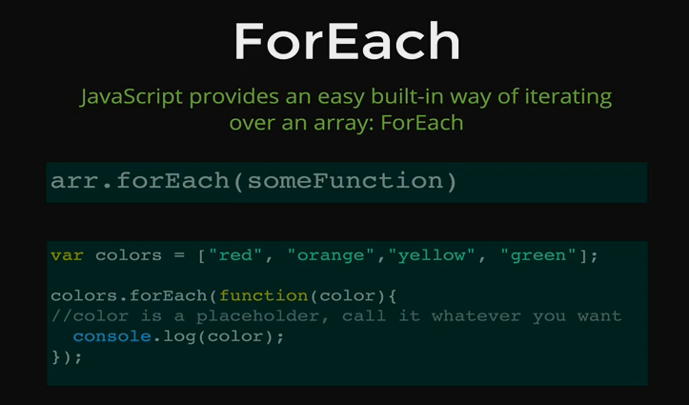

* **Object** are stored in a key-value pair. For example -> var person = {name: ”cindy” ,age: 32, city: “dhaka”}; To access a data -> person[“name”] or person.name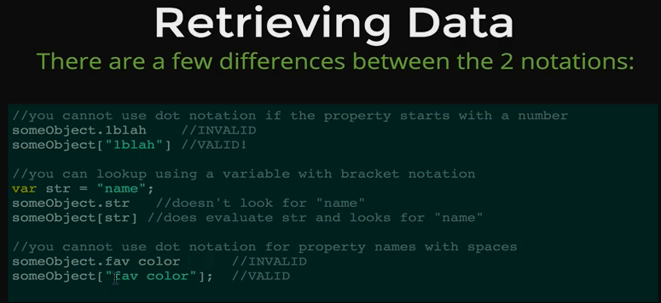
* **Creating** -> var person = new object (); person. Age=21; and so on /

var person = {name:” Cindy”, age: 32, city: “Dhaka”};

var person= {}; person.name=” Cindy”;

* **Nested Objects** -> example of an object of post